EN - 2160 Electronic Design Realization

SolidWorks Design



Name: **Gunawardana W. N. M**

Index No: 210199D

Date of Submission: 2024.02.29

1. **Full Overview**

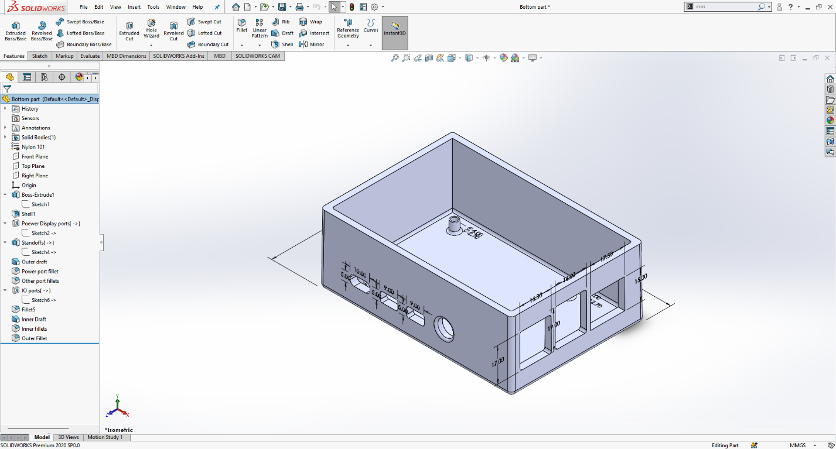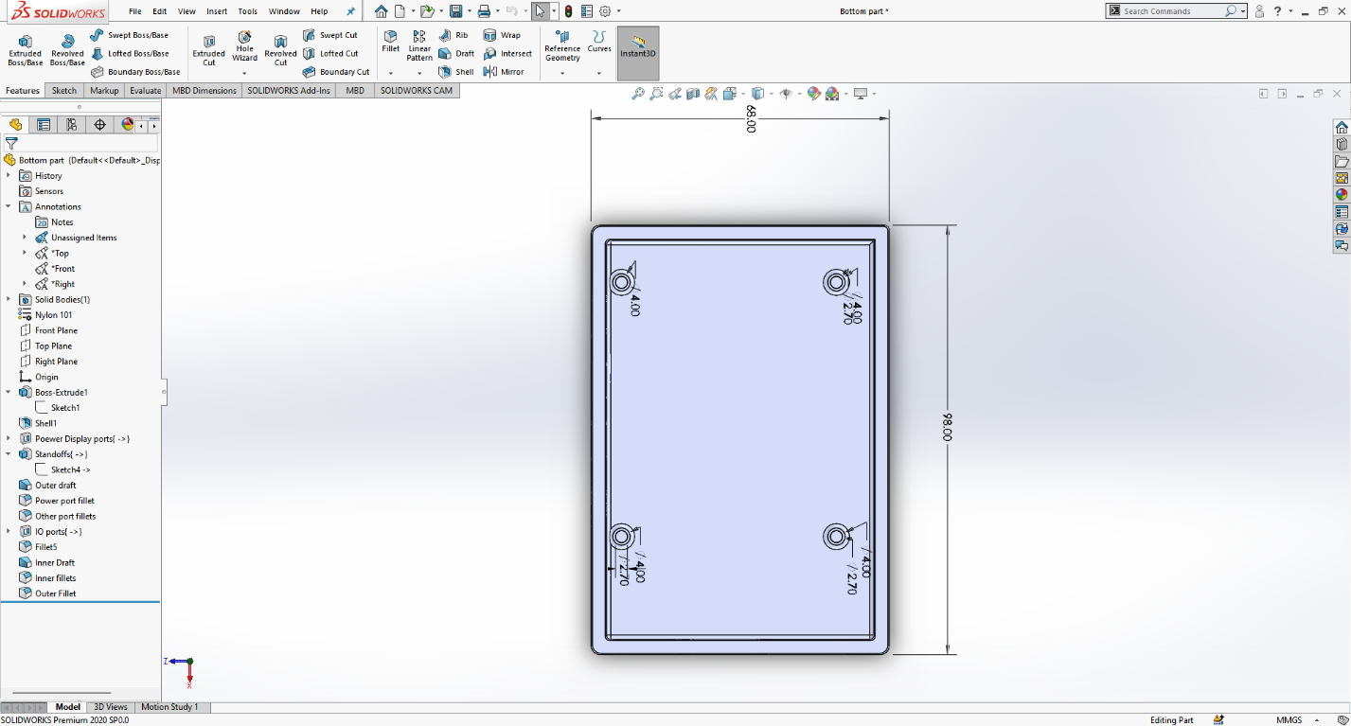

1. **Sketch 1**

1. **Sketch 6**

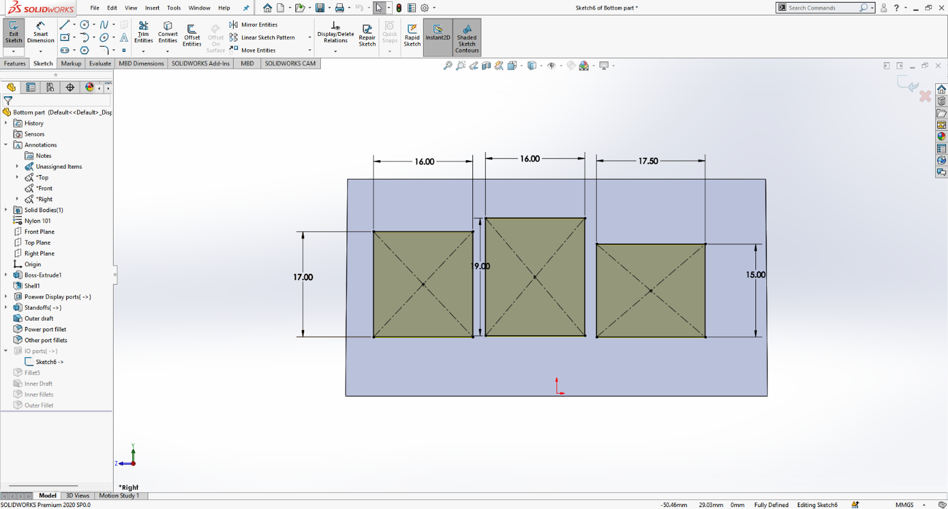

1. **Sketch 2**

1. **Sketch 4**

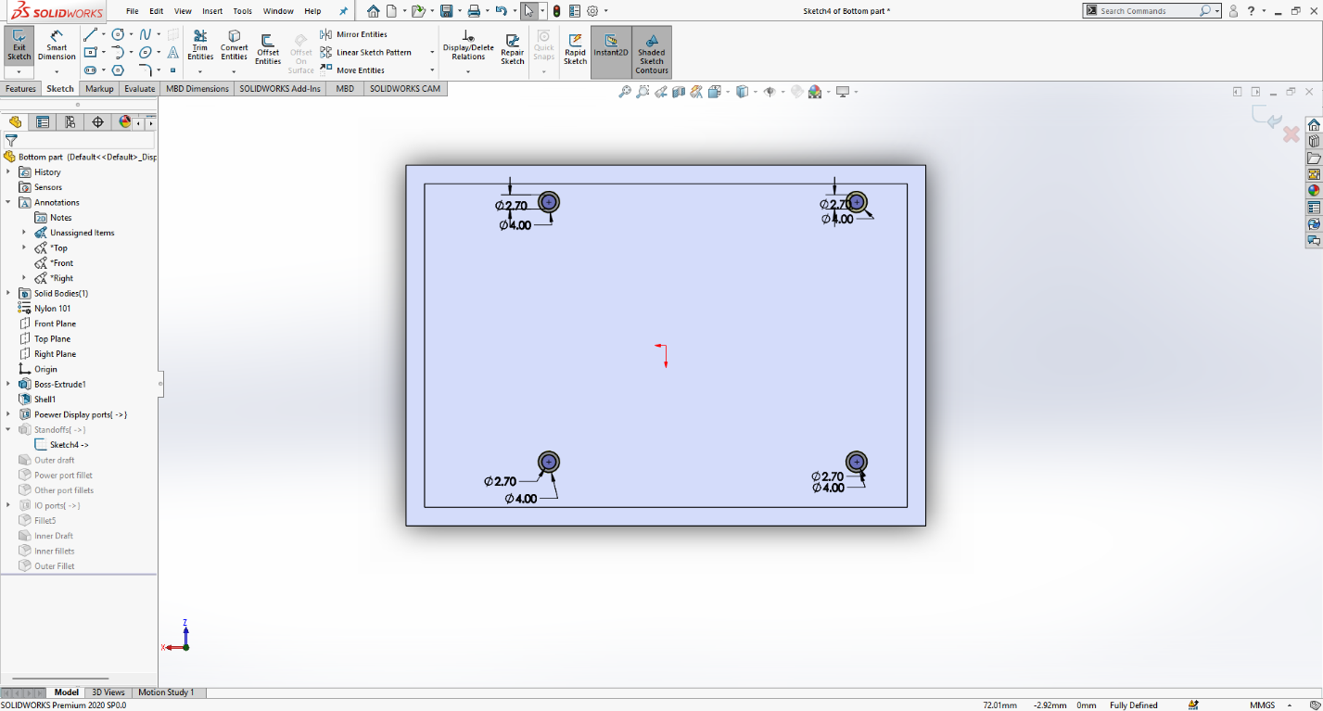

1. **Cross-sectional view**

0.5 deg draft angle is added since they are 90deg planes.